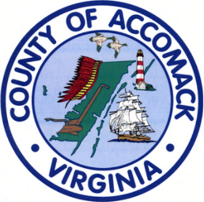

**Agenda**

Accomack County Electoral Board Meeting

October 17, 2023 2:00

Parks and Recreation Bldg. Sawmill Park

24387 Joynes Neck Rd. Accomac, VA 23301

Attendees:

Electoral Board Members

Nancy Carroll-Chair

Martha Sutherland-Vice Chair

Roger Omwake-Secretary

General Registrar/Director of Elections

Angel Shrieves

Call Meeting To Order

* Welcome guests

Agenda Topics

* Reading and approval of minutes of previous meeting
* Registrar’s Report
* Old business

Same Day Registration Process during Canvas

* New business
* Comments by the public

Adjourn Meeting