MINUTES OF THE
ACCOMACK-NORTHAMPTON
TRANSPORTATION DISTRICT COMMISSION

A regular meeting of the Accomack-Northampton Transportation District Commission was held at the Eastern Shore Chamber of Commerce Office, Melfa, Virginia, on Tuesday, February 6, 2024, at 5:30 p.m.

Present:

Donald L. Hart, Jr., Chairman (via phone)
C. Reneta Major, Secretary-Treasurer
Ernest L. Smith, Jr.

Absent:

John R. Coker, Vice Chairman
Oliver H. Bennett
(Vacant Accomack appointee)

Ex-Officio member absent:

Linda Balderson

Nonmembers present:

George Mapp, Eastern Shore Rail Trail Foundation
Bruce Simms, Virginia Regional Transit
Bill Moore, STAR Transit
Jason Olivo, VRT/START
Sid Camden, Buckingham Branch Railroad
Jackie Phillips, Canonie Atlantic Co.
Jim Outland, Canonie Atlantic Co.
H. Spencer Murray, Canonie Atlantic Co.
Ron Wolff, Canonie Atlantic Co.
Steve Johnsen, citizen
Baron Emery, Delmarva Central Railroad
Damion Geist, NRHS
Anne Doyle, ANPDC

In Re: Call to Order

Ms. Major, the Secretary-Treasurer, opened the meeting due to the Chairman’s illness (listening on the phone, but ill), and the absence of the Vice Chairman. She indicated that while there was no quorum present, the body could receive presentations but could not take any actions.

In Re: Invocation

The invocation was given by Mr. Phillips.

In Re: Statements from the Public

There were no statements from the public.

In Re: Account Balances

The monthly Assistant Secretary-Treasurer's report showed an ending balance at January 31st of $75, 575.87.

In Re: Minutes of January 2, 2024

Due to lack of a quorum, this item will be considered at the next meeting.

In Re: Public Transportation Report

The following Management Report was distributed:


STAR Transit Management Report
February 6th 2024

Operations

- Due to the timing of month end, January 2024 ridership totals will be delivered at the February 2024 ANTDC meeting.

- During the month of January, a ride-a-long audit of STAR Transit’s service was conducted. Results of this and financial reviews will be delivered at the February 2024 ANTDC meeting.

Human Resources

- STAR Transit has certified its second ELDT program participant for their commercial driver’s license and passenger endorsement. As a result of this program, the employee successfully passed both their pre-trip and behind the wheel examination at the Department of Motor Vehicles testing facility.

Marketing and Outreach

- STAR Transit has provided to both Accomack and Northampton Counties FY25 budget request information as appropriate. During the month of February, STAR Transit representatives will be present at each hearing to field questions and highlight STAR Transit’s record setting FY23 ridership.

Training

- Training during the month of January and February are centered upon completing STAR Transit’s annual Drug and Alcohol Training as required by the STAR Transit D&A Policy. All employees will have completed this training module by February 16th.

Transit Capital and Infrastructure

- STAR Transit has received three new replacement buses during the month of January purchased through FY22 and FY23 grants. Once these vehicles are fully outfitted and placed in to service, the retiring buses will be sold at public online auction.

- A Transit Development Plan update worksheet was completed in January 2024 and delivered to DRPT to assist in long range planning of capital expenditures.

Monthly Ridership Statistics

October 2022 7206 October 2023 9323
November 2022 7538 November 2023 8701
December 2022 7462 December 2023 7462
January 2023 7992 January 2024 8479*

* Of this, Perdue accounted for 659 passengers in January and 567 in December.

* * * * *

 |  |  |  |  | 31-Dec-23
STAR TRANSIT 2023-2024
 |  |  |  |  | Passengers
Month | Total Revenue | Total Expenses | Surplus/Deficit |  | Month |  | 2023-2024 |  | 2022-2023 Trips | Total Cost
Oct. | $115,850.96 | $95,960.85 | $19,890.11 |  | Oct. |  | 9,323 |  | 7,206 | $10.29
Nov. | $137,304.35 | $141,870.26 | -$4,565.91 |  | Nov. |  | 8,701 |  | 7,538 | $16.31
Dec. | $119,276.11 | $104,535.78 | $14,740.33 |  | Dec. |  | 7,672 |  | 7,462 | $13.63
Jan. |  |  | $0.00 |  | Jan. |  |  |  | 7,992 | #DIV/0!
Feb. |  |  | $0.00 |  | Feb. |  |  |  | 7,408 | #DIV/0!
Mar. |  |  | $0.00 |  | Mar. |  |  |  | 8,009 | $0.00
Apr. |  |  | $0.00 |  | Apr. |  |  |  | 7,691 | $0.00
May |  |  | $0.00 |  | May |  |  |  | 8,880 | $0.00
June |  |  | $0.00 |  | June |  |  |  | 7,801 | $0.00
July |  |  | $0.00 |  | July |  |  |  | 7,332 | $0.00
Aug. |  |  | $0.00 |  | Aug. |  |  |  | 8,644 | $0.00
Sept. |  |  | $0.00 |  | Sept. |  |  |  | 8,491 | $0.00
 |  |  |  |  |  |  | 25,696 |  | 94,454
TOTAL | $372,431.42 | $342,366.89 | $30,064.53 |  | AVERAGE COST PER PASSENGER -> |  |  |  |  | $13.32
 |  |  |  |  | AVERAGE PASSENGERS PER MONTH -> |  |  |  |  | 8,565
Passengers per Mile |  |  |  |  | Cost per Mile
Oct. | 0.21 | April | #DIV/0! |  | Oct. |  | $2.14 |  | April | #DIV/0!
Nov. | 0.20 | May | #DIV/0! |  | Nov. |  | $3.32 |  | May | #DIV/0!
Dec. | 0.18 | June | #DIV/0! |  | Dec. |  | $2.42 |  | June | #DIV/0!
Jan. | #DIV/0! | July | #DIV/0! |  | Jan. |  | #DIV/0! |  | July | #DIV/0!
Feb. | #DIV/0! | Aug. | #DIV/0! |  | Feb. |  | #DIV/0! |  | Aug. | #DIV/0!
Mar. | #DIV/0! | Sept. | #DIV/0! |  | Mar. |  | #DIV/0! |  | Sept. | #DIV/0!
 |  |  |  |  | TOTAL
AVERAGE MONTHLY PASSENGERS PER MILE |  |  | 0.20 |  |  |  | AVERAGE COST PER MILE |  |  | $2.61
Hourly Cost |  |  |  |  | Passengers per Hour
Oct | $54.90 | April | #DIV/0! |  | Oct |  | 5.3 |  | April | #DIV/0!
Nov. | $85.30 | May | #DIV/0! |  | Nov. |  | 5.2 |  | May | #DIV/0!
Dec. | $66.75 | June | #DIV/0! |  | Dec. | 1 | 4.9 |  | June | #DIV/0!
Jan. | #DIV/0! | July | #DIV/0! |  | Jan. | 1 | #DIV/0! |  | July | #DIV/0!
Feb. | #DIV/0! | Aug | #DIV/0! |  | Feb. |  | #DIV/0! |  | Aug | #DIV/0!
March | #DIV/0! | Sept | #DIV/0! |  | March |  | #DIV/0! |  | Sept. | #DIV/0!
TOTAL
 | AVERAGE TOTAL HOURLY COST |  | $68.79 |  | AVERAGE PASSENGERS PER HOUR |  |  |  |  | 5.2
 | Budget CPH |  | $ 60.00
 | Route Location | Passenger Totals | Operating Hours |  | Mileage
 | Red | 1,019 | 208.00 |  | 6,091
 | Purple | 1,108 | 203.00 |  | 5,676
 | Gold | 835 | 98.00 |  | 2,879
 | Gold H2Expansion | 811 | 118.00 |  | 3,633
 | Accomack On Demand(Green) | 533 | 178.00 |  | 3,906
 | Blue | 683 | 123.00 |  | 3,246
 | Blue H2Expansion | 551 | 108.00 |  | 3,923
 | Silver | 756 | 238.00 |  | 6,385
 | Yellow | 1,086 | 208.00 |  | 4,733
 | Rt.13 Express | 290 | 84.00 |  | 2,808
 |  | 7,672 | 1,566.00 |  | 43,280
Month | Hrs. of Oper. | Mileage | Budget Hrs
Oct. | 1,747.90 | 44,946
Nov. | 1,663.20 | 42,721
Dec. | 1,566.00 | 43,280
Jan.
Feb.
Mar.
Apr.
May
June
July
Aug.
Sept.
 | 4,977.10 | 130,947 | 0

* * * * * *

In Re: State’s Comments

Ms. Balderson was absent.

In Re: Melfa Airport Update

Mr. Hart provided no report.

In Re: Wallops Update

Mr. Wolff noted that things are moving quickly with Rocket Lab and its anticipation of up to 40 launches per year.

In Re: Railroad Comments

Mr. Emory of DCR provided the following car count and related comments:

Coastline Chemical 25
Perdue Agribusiness 20
Sharp Energy 5
Trigas 12
Total 62

Mr. Sid Camden of BBRR said that Little Creek experienced a good start for the new year.

In Re: VDOT Report

Mr. Chris Isdell, Residency Administrator of VDOT was absent.

In Re: FY 2023 Audit Presentation

Ms. Kara Doyle of Mitchell, Burns & Co., PC., shared with the Commission the following powerpoint presentation:

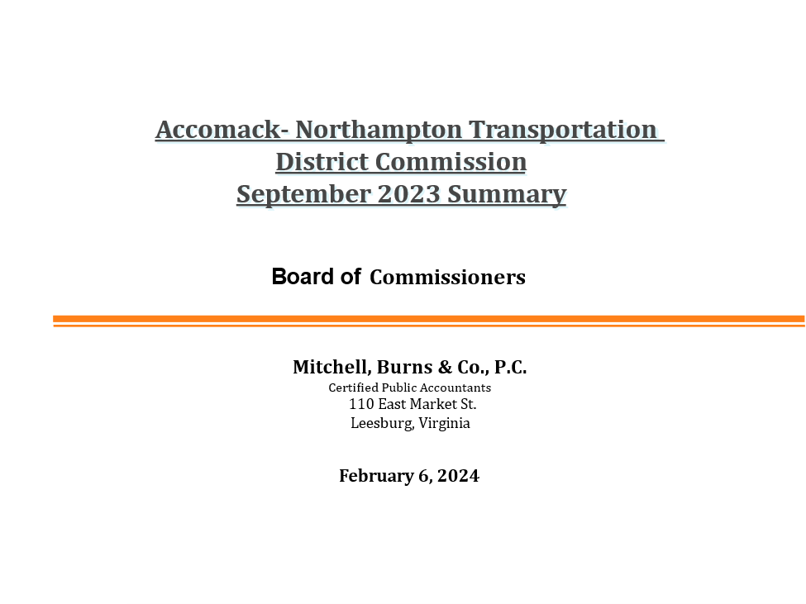

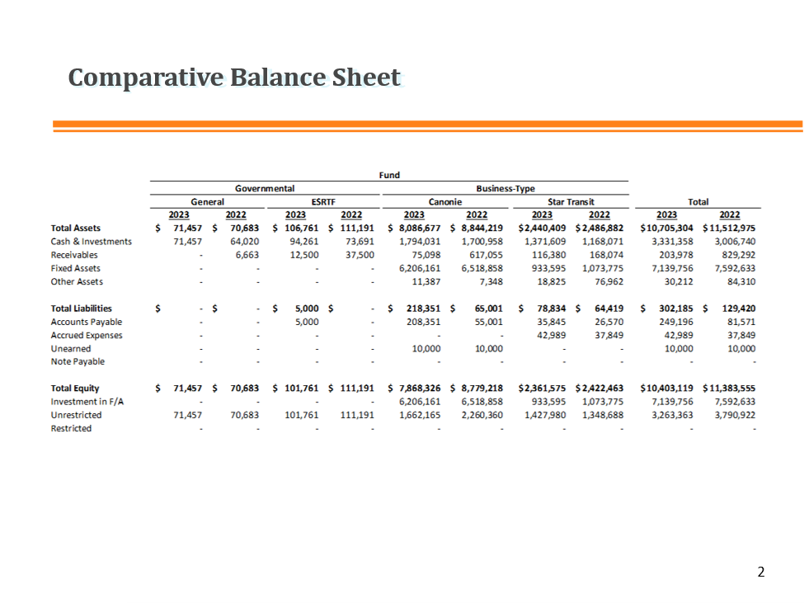
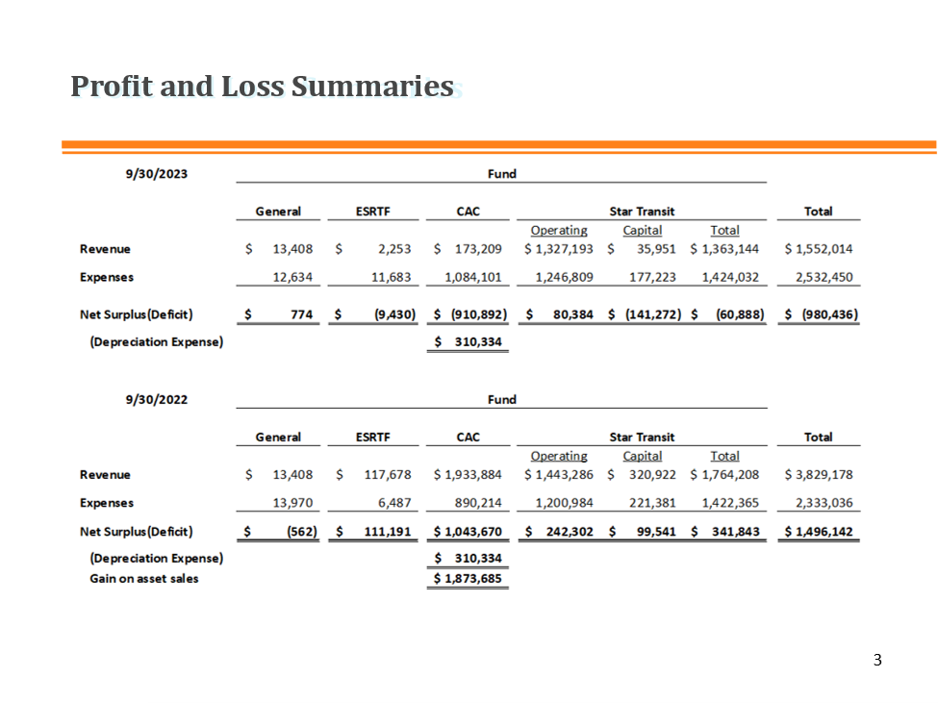
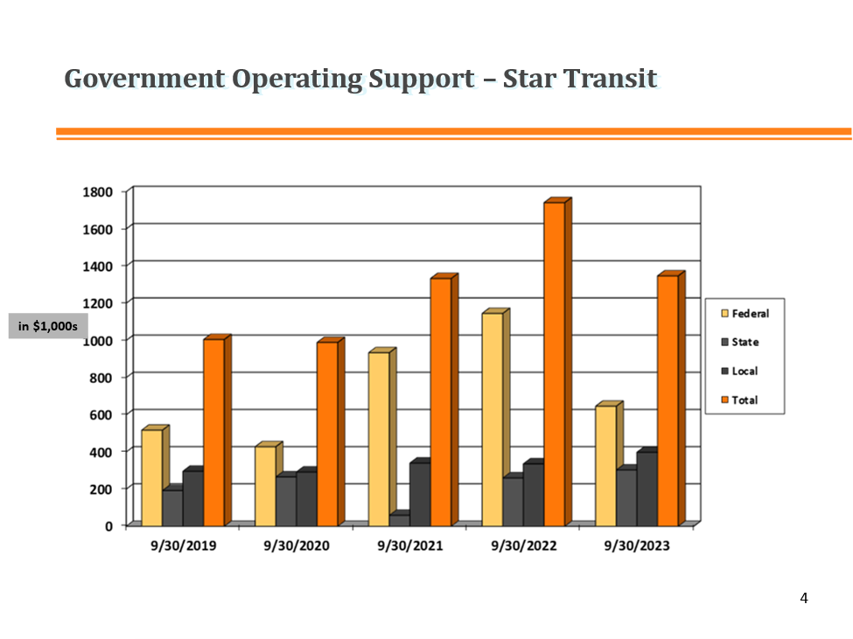
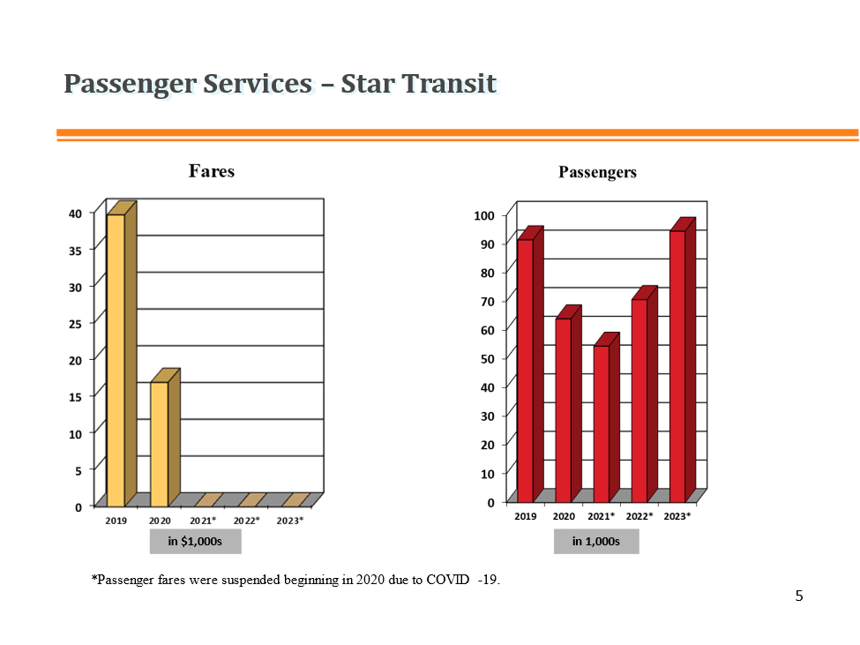

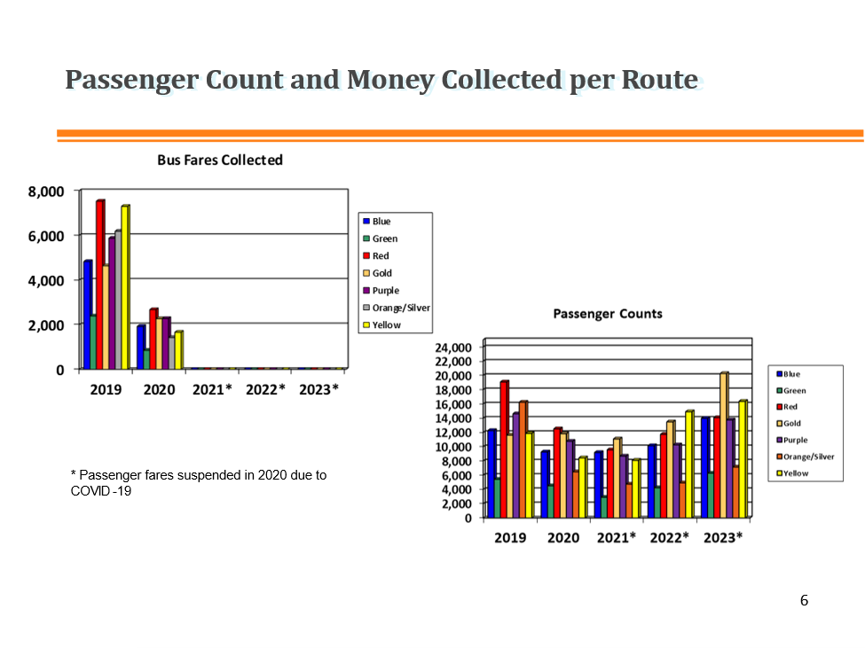

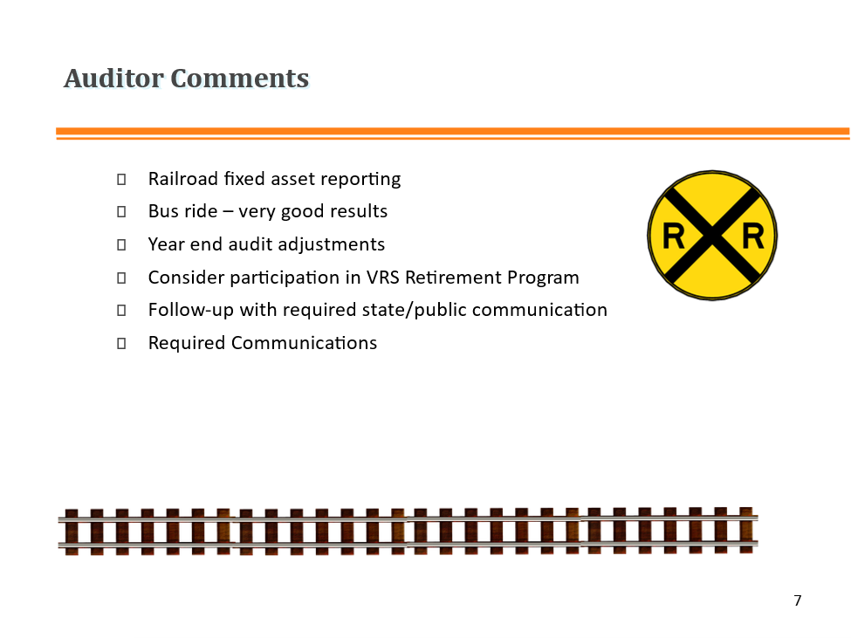
Mr. Spencer Murray of Canonie Atlantic Co. said that for next year, he would like to see inclusion of a Management Letter within the CAC audit. Ms. Doyle indicated that this was certainly possible.

Due to lack of a quorum, action on adoption of the audit will be considered at the next regular meeting.

In Re: Recess/Adjourn

The meeting was adjourned.

